DEPARTMENT MANAGEMENT SYSTEM

**AIM:** To generate a database having the information about computer science department including faculty details.

**Software Used:**

-SQL

-SQL Server Management Studio

-Visual Studio 2017 using VB.NET framework

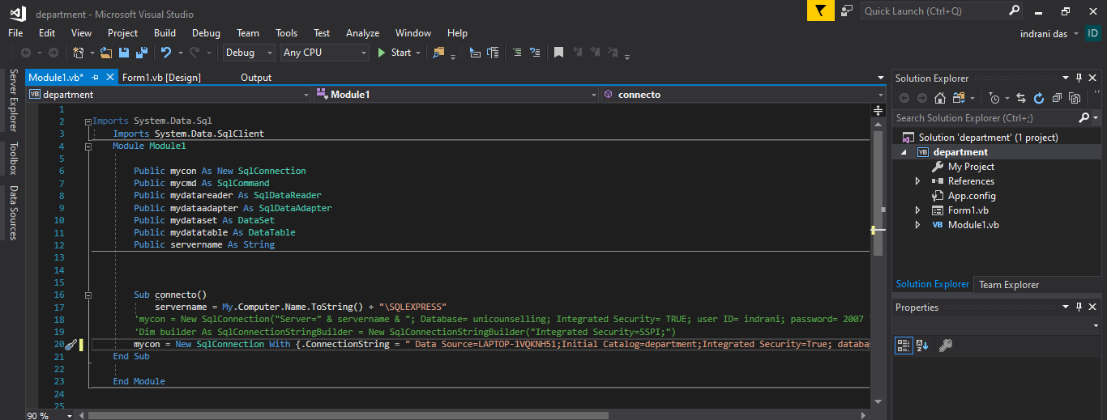**CONNECTION MODULE:**

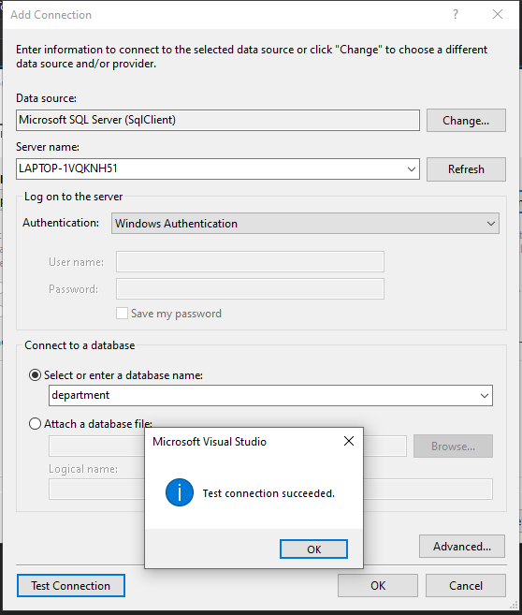

**Screenshots:**

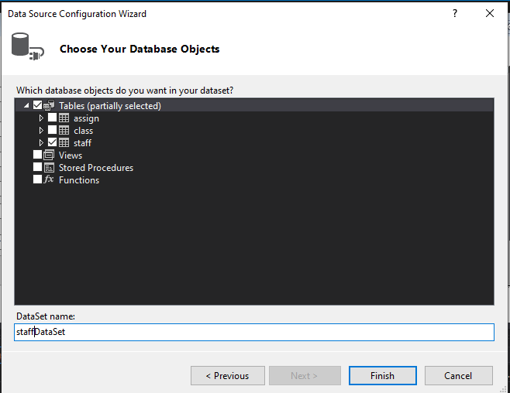

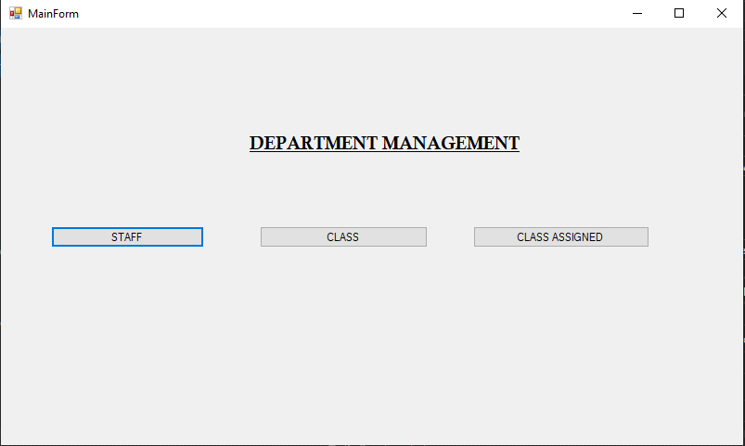

STAFF TABLE:

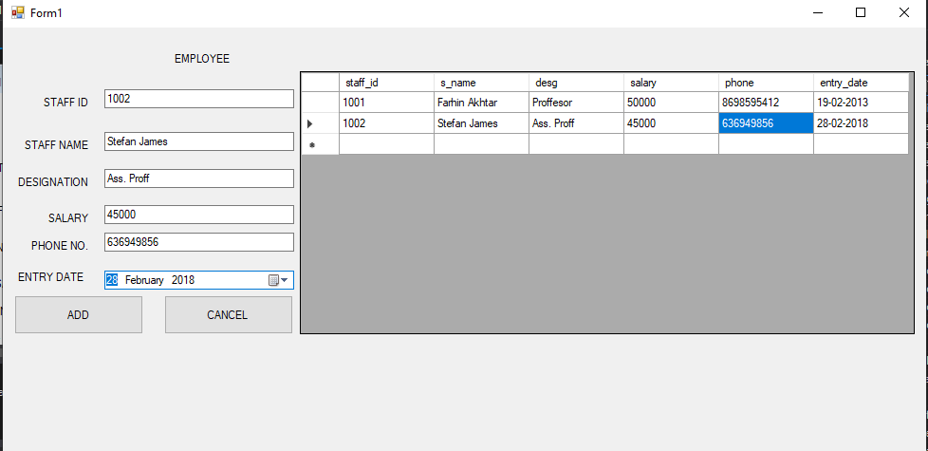

CLASS TABLE:

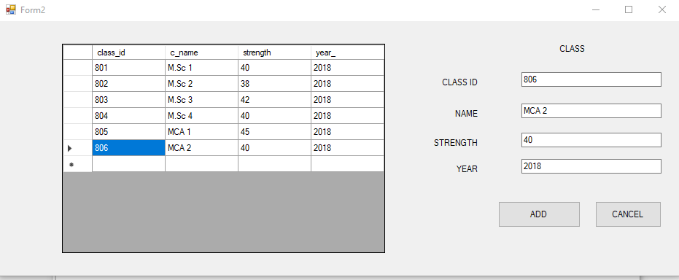

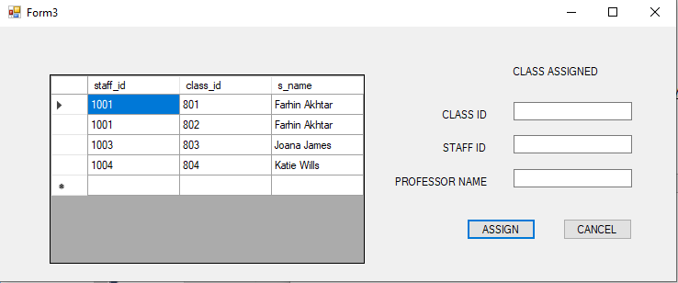CLASS ASSIGNED: